

WEATHER DATA ANALYSIS AND FORECASTING

Trainee Name Trainee Code
NOUFIYA JN 6332
VANDHANA RAM S 6341
VISAKHI VA 6342


Ai micro degree
NSTI (W) Trivandrum, 2025 - 2026

CERTIFICATE
This is to certify that the project design report on “WEATHER DATA ANALYSIS AND FORECASTING” is an authentic record of the project design done by NOUFIYA JN, VANDHANA RAM S, VISAKHI VA of AI Micro Degree, towards the partial fulfilment of the requirement as a part of this course.

Head of the Department Guided by
Smt. DHANYA RAVEENDRAN Smt. RISHITHA R
Training Officer Guest Lecturer
CSA Section In-Charge AI Micro Degree
NSTI (W) TVM NSTI (W) TVM

DECLARATION
We, NOUFIYA JN, VANDHANA RAM S and VISAKHI VA do hereby declare that the project report titled "WEATHER DATA ANALYSIS AND FORECASTING" submitted by me is a bona fide record of the work carried out by me as part of my academic project under the guidance of RISHITHA R in partial fulfilment of the requirements for the award of the Ai Micro Degree, AI Programming Assistant from NSTI (W) TVM. This report has not been submitted previously by me or any other person for any degree, diploma, or other similar title at any other institution or university. We have ensured that the work presented is original and properly referenced wherever necessary.

Trivandrum
25/02/2026

Trainee Name Trainee Code
NOUFIYA JN 6332
VANDHANA RAM S 6341
VISAKHI VA 6342

ACKNOWLEDGEMENT
Firstly, we would like to thank all those who have contributed to the completion of the project and helped us with valuable suggestions for improvement. we express my sincere gratitude to Sri. M SARAVANA, Principal, Nation, for providing the opportunity and the environment to present this seminar. I extend my sincere thanks to Smt. DHANYA RAVEENDRAN, Head of the Department of Electrical and Electronics Engineering, for providing me the best facilities and atmosphere for creative work guidance and encouragement. I would like to thank my coordinator, Smt. RISHITHA R, Guest Lecturer in AI Micro Degree, for her well- timed help and support.
We would like to thank all our teaching and non-teaching staff of the National Skill Training Institute (Women) for cooperating with us for extending their warm kindness and help.
We are grateful for our family and friends for their support and encouragement during the preparation of the work.
And above all we would like to express our gratitude to the almighty, without whose blessings we would not have completed this work.

TABLE OF CONTENT
- INTRODUCTION.………………………………………………………… 5
- ABSTRACT…………………………………………………………………. 6
- OBJECTIVE…………………………………………………………………. 7
- METHODOLOGY…………………………………………………………. 7 - 8
- PROBLEM STATEMENT………………………………………………… 9
- TOOLS USED……………………………………………………………… 9 - 11
- DATA DESCRIPTION……………………………………………………. 11
- DEMONSTRATION STEPS....................................................................... 12 - 19
- INSIGHTS AND FINDINGS……………………………………………. 20
- FUTURE SCOPE…………………………………………………………… 20
- CONCLUSION……………………………………………………………... 20 - 21
- REFERENCE………………………………………………………………… 21

INTRODUCTION
Agriculture depends a lot on the weather and climate stuff. Things like temperature and rainfall really affect how crops grow and how much they produce. Soil quality matters too, along with humidity and even the CO2 in the air. I think even tiny changes in all that can mess up when plants germinate or flower or get harvested. It is not hard to see why.
In places like India, where so many farmers count on the monsoons and steady weather, this gets serious. Millions of people in rural areas depend on farming for their lives. Food security hangs in the balance when the rains do not come right. Livelihoods suffer too, it seems.
Over the last few decades, things have changed. Global warming is happening, CO2 levels keep rising. Monsoons are irregular now, droughts last longer, and extreme events pop up more. All of this makes farming unpredictable. Production is not as reliable as it used to be.
That is why looking at old data on agriculture and climate makes sense. Historical trends can show what is going on over time. Then you can try to predict future crop yields. It might help a bit.
Farmers could use insights for planning what to plant. Irrigation strategies might improve with that info. Researchers and policymakers too, they could think about adaptation to climate changes. Some people say it is key for decisions, others maybe doubt how much it helps right away. This part feels a little messy to me, not totally clear on the best ways yet.

ABSTRACT
Agriculture is really important for keeping people fed around the world, and it helps economies run too, especially in places like India where so many folks rely on farming to make a living. I mean, without it, food security would be a huge problem, plus it creates jobs and gives raw stuff to factories, and even boosts the overall economy in terms of GDP or whatever. But lately, climate change has been throwing everything off, making it hard to farm reliably.
Things like temperatures going up, rain not coming when it should, more CO2 in the air, and all these crazy weather events happening more often, droughts or floods or heat that just won’t quit, they mess with how crops grow. It affects the soil, water supply, when pests show up, all that. Crop yields end up all over the place, which is risky for food chains and keeping money flowing steadily. It seems kind of scary how unpredictable it’s getting.
For this project, I’m looking into data to see exactly how these climate things hit crop productivity. The main factors I want to check out are average temperature, how much rain falls each year, CO2 emissions levels, and how often extreme weather hits. Then there is the historical data on crop yields to compare against. I think that should show some patterns, though I’m not totally sure yet how clear it will be. Some people say it’s already too late in certain areas, but others think we can adapt somehow

OBJECTIVE
Here's what we aim to achieve with this project:
- Clean up and get the agricultural dataset ready for analysis.
- Figure out how climate and crop yields relate to each other.
- Spot trends by visualizing data over time.
- Pinpoint the most important things that affect how much crops we get.
- Develop a basic model that can predict future crop yields.
- Offer helpful information for planning agriculture in a way that's sustainable.
METHODOLOGY
- Data Collection
We put together a dataset with historical info on agriculture and climate, including: -
- Year
- Country
- Crop Yield (MT per HA)
- Temperature
- Precipitation
- CO₂ emissions
- Extreme weather events
- Soil health index
- Irrigation access

- Data Preprocessing
- No missing values in the dataset.
- Null values were handled by replacing them with the mean.
- We got rid of any inconsistencies.
- The data was converted into formats that work.
- Exploratory Data Analysis (EDA)
- We figured out the average crop yield.
- We analyzed yield by country.
- We looked at trends over the years.
- A correlation heatmap was created.
- Data Visualization
- We used graphs like:
- Line plots (Trend analysis).
- Bar cHarts (Country comparison).
- Heatmaps (Correlation analysis).
- Forecasting Model
- We utilized Linear Regression.
- The model was trained using historical yearly yield data.
- Crop yield was predicted for the next 5 years.
- The forecast results were visualized.
Data Preprocessing
Handle Missing Values
Remove Duplicates
Feature Scaling
Data Collection
Climate Data (Temperature, Rainfall,
CO2 Emission)
Crop Yield Data




Insights and Conclusion
Climate Impact Findings
Sustainable Planning Support
Exploratory Data Analysis
Trend Analysis
Data Visualization
Summary Statistics





Forecasting and Prediction
Future Yield Prediction
Trend Projection
Soil Availability
Correlation Analysis
Heatmap
Correlation Matrix
Identify Key Factors

PROBLEM STATEMENT
Climate change is really messing with how well farms produce food globally, which makes things pretty unpredictable. But the problem is that farmers and those making the rules often don't have the solid, reliable information they need to figure out exactly how changes in temperature, rainfall, and crazy weather might affect how much they can grow in the future.
- Investigate how climate factors impact crop production.
- Pinpoint past patterns in agricultural output.
- Predict what future yield trends might look like.
- Promote environmentally conscious agricultural strategies.
- Guarantee stable food supplies for the future.
TOOLS USED
The project was implemented using the following tools and
technologies, each playing a specific and important role in the data
science workflow:
- Python For this project, we're mainly using Python as our programming language. It's a popular choice in data science because it's easy to read and write, plus it has a ton of helpful libraries. Python makes it easier to work with data, create visuals, and build machine learning models. Since it's pretty straightforward for beginners, it's perfect for school and research projects.

- NumPy is the go-to library for performing mathematical and numerical calculations. It's built to support multi-dimensional arrays and a wide range of math functions. What's more, NumPy boosts both the speed and efficiency of computations.
- Performing statistical calculations
- Handling numerical transformations
- Working with arrays in regression modeling
Supporting mathematical operations required for machine learning algorithms

- Matplotlib is a go-to tool for whipping up fundamental visualizations such as:
- Line plots - great for spotting trends
- Bar charts - perfect for comparing things like countries
- Histograms - ideal for checking out distributions
- Scatter plots - awesome for seeing how variables relate to each other
These visuals are super helpful in making sense of patterns trends, and the connections between climate stuff and how well crops grow.

- Seaborn: Statistical Visualization Made Easy
Built upon Matplotlib, Seaborn takes your visualizations to the next level with advanced statistical tools.
In this project, Seaborn powers:
- Correlation heatmaps that reveal variable relationships
- Regression plots to spot trends in the data
  - Boxplots that pinpoint outliers
  - Distribution plots that show data spread
It elevates visual clarity and ensures a more aesthetically pleasing and insightful view into statistical relationships.

- Scikit-learn - Machine Learning (Linear Regression)
Scikit-learn is the tool we'll use for building and checking our predictive model. It's great because it gives us simple, effective ways to do machine learning.
In our project, we're using Scikit-learn to:
- Split our data into training and testing sets
- Run a Linear Regression
- See how well our model performs using R² Score and Mean Squared Error
- Come up with predictions for future crop yields
It's set up so that even people new to this can easily use machine learning algorithms without things getting too complicated.

- Jupyter Notebook serves as our interactive coding space. It's great because it lets you:
- Write and run Python code bit by bit.
- Show results, tables, and cool visualisations right there.
- Mix code, explanations, and what you get all in one place.

- Anaconda Navigator is a big help too, because it's good for:
- Organising different Python setups.
- Getting the libraries you need installed.
- Starting Jupyter Notebook without a fuss.
- Sorting out which packages work with each other.
Combined, these make setting up a data analysis or machine
learning project easy, especially when you're just starting.

DATA DESCRIPTION
This dataset encompasses several years' worth of agricultural information from a variety of countries.

Column Name | Description
Year | Year of observation
Country | Country name
Crop Yield MT per HA | Crop production per hectare
Average Temperature | Average yearly temperature
Precipitation | Annual rainfall
CO2_Emissions | Carbon dioxide emission levels
Extreme Weather Events | Number of extreme climate events
Soil Health Index | Soil fertility indicator
Irrigation Access | Percentage of irrigated land
DEMONSTRATION STEPS
- Open Anaconda Navigator.
  - Click on the search button and type Anaconda Navigator.
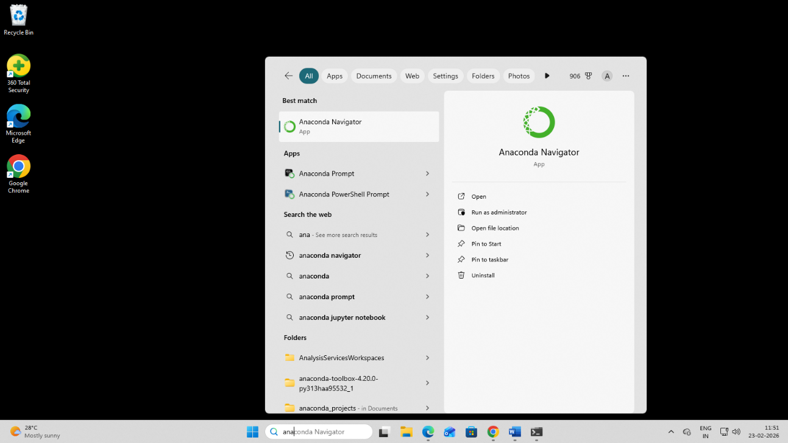



- Launch Jupyter Notebook.
  - Go the home page Anaconda Navigator.
  - Click on the launch option of Jupyter Notebook.
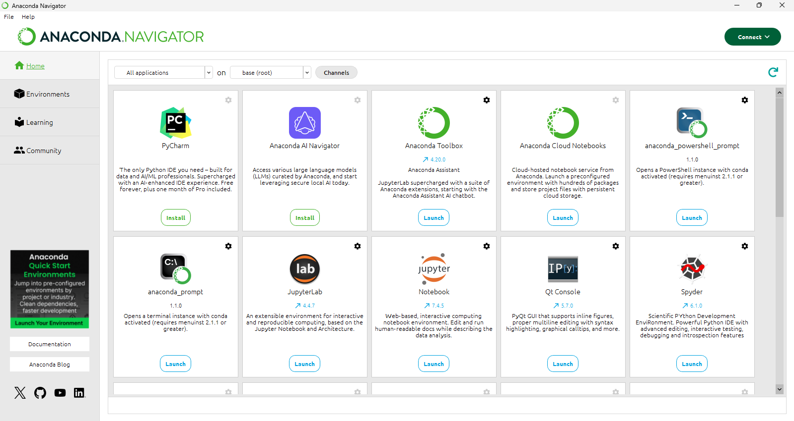

  - On the home page create a new folder named “Introduction to Data science”.
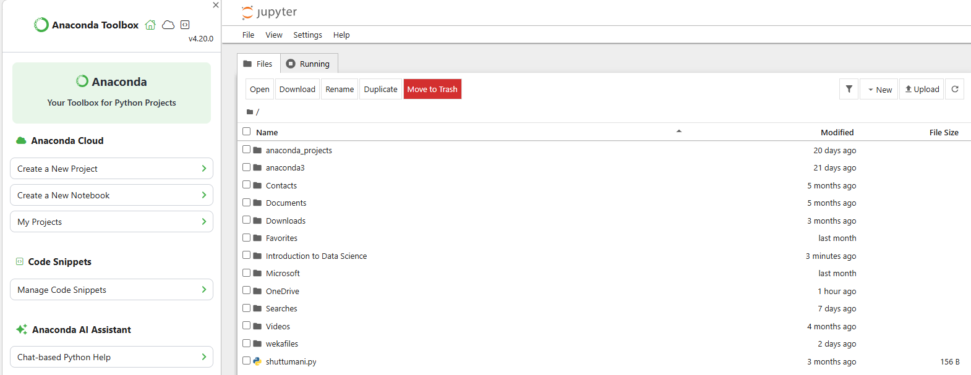

  - Now create a new workbook named ‘Lab 1’ in the folder to do operations.
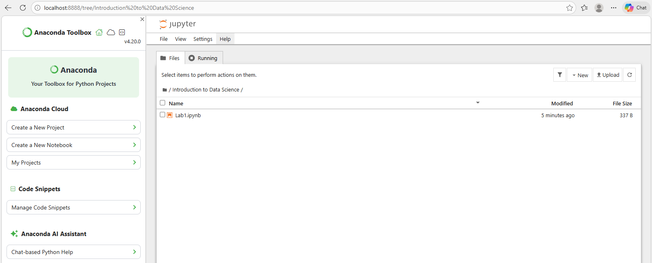

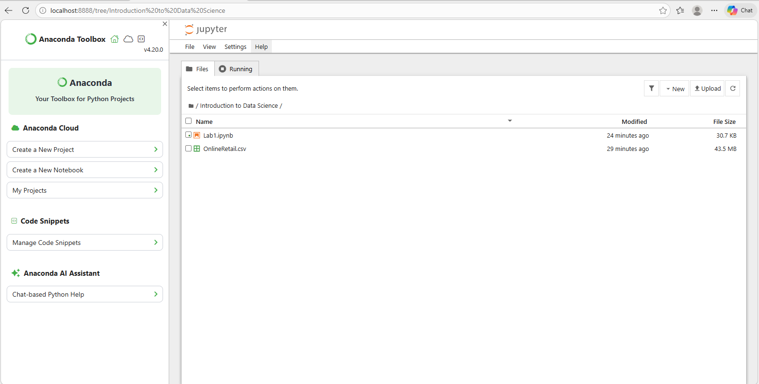
  - Import the dataset to the folder.

  - Open the notebook to do operations.
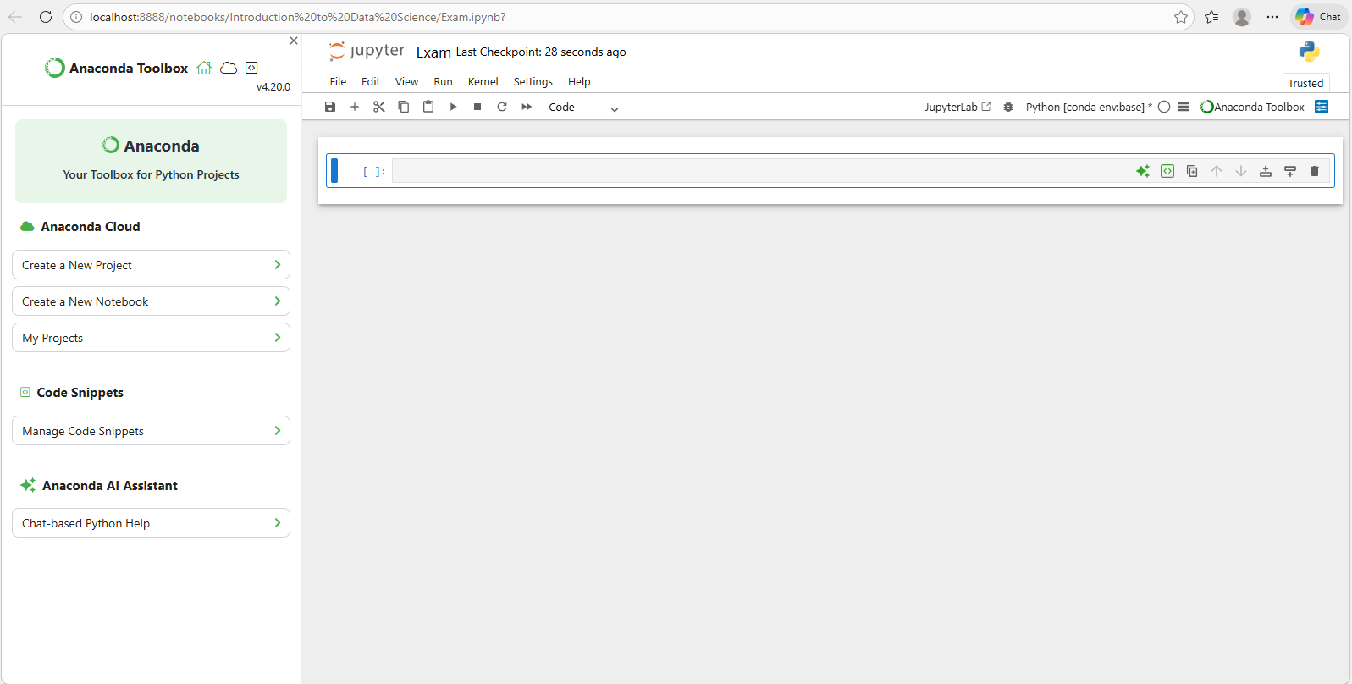

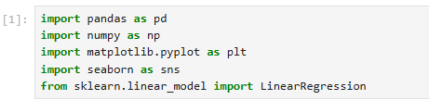
- Importing libraries.

- Loading the dataset.

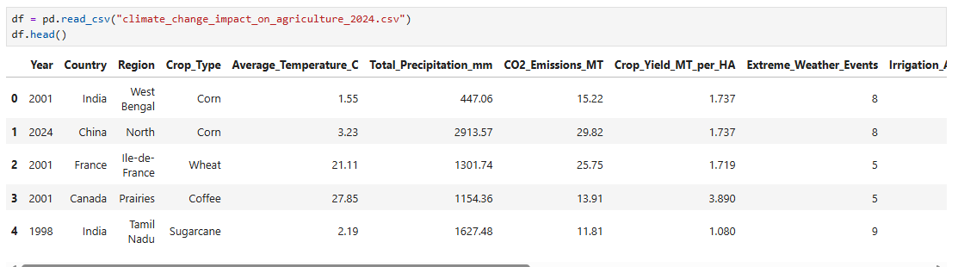

- Understanding the dataset.
  - Checking missing values.
  - Checking data type.
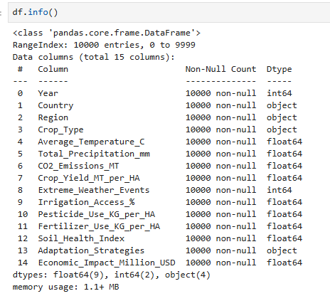
  - Understanding numerical distribution.

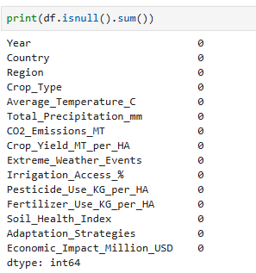


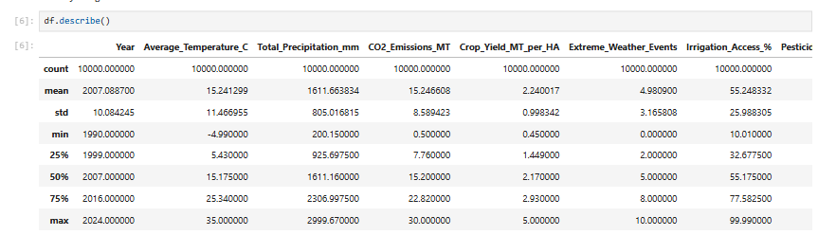

- Finding Average Crop Yield.
- Purpose – Finds the overall average yield across all countries and years.
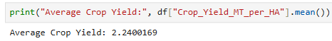
- Use - Gives a quick benchmark for understanding productivity levels.

- Crop Yield by Country.
- Purpose - Calculates average yield for each country.
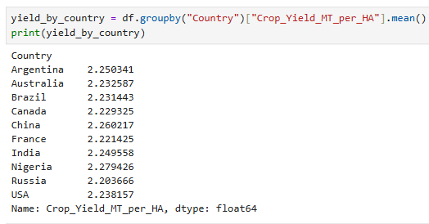
- Use - Helps identify which countries are more productive and which need improvement.

- Correlation Between Climate Factors and Crop Yield
- Purpose: Shows how strongly different variables are related.
- Use: Helps understand how climate variables (temperature, rainfall, CO₂, etc.) impact crop yield.

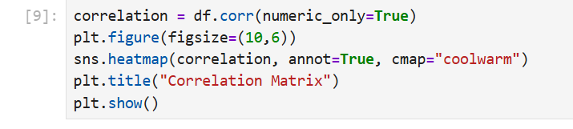

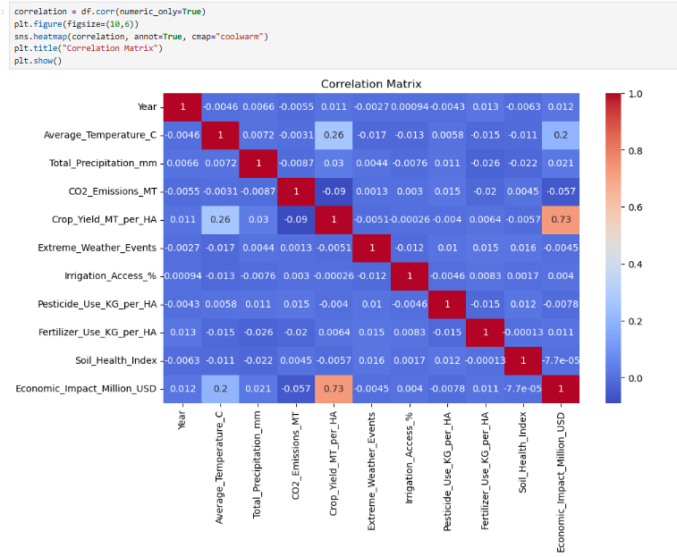

- Crop Yield Trend Over Years
- Purpose: Indicates how crop yield is changing over time.
- Use: Enables the discovery of patterns to aid planning and forecasting.
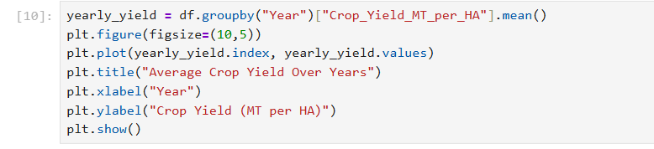

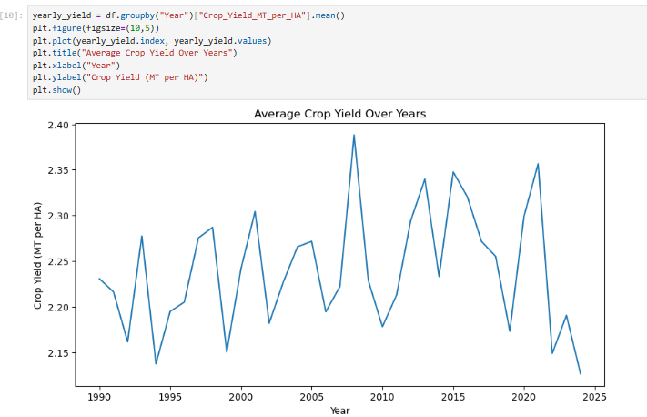

- Prepare Data for Forecasting
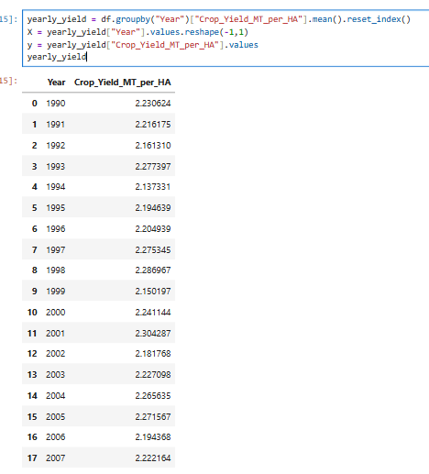
- Purpose - Prepares data in the format required for Linear Regression.
- X = Years, y = Yield
- Use - Helps the model understand how yield depends on time.


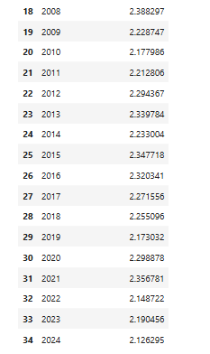


- Predict Future Yield (Next 5 Years)
- Purpose: Estimates crop yield for upcoming years based on historical trends.
- Use: Helps policymakers and farmers plan for the future.
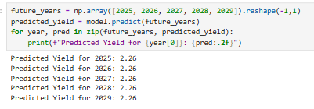

- Forecasting
- Purpose: Visualizes both historical and predicted yields in one chart.
- Use: Easy to see trends and make data-driven decisions.
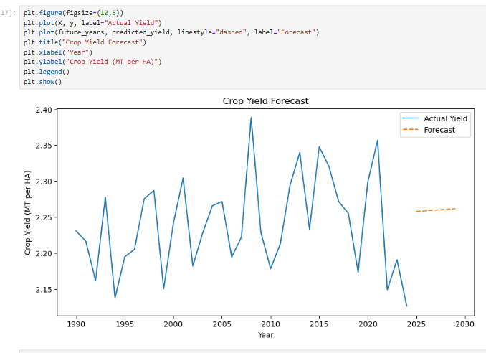

- Crop Yield Trend Over Country
- Purpose: Visualizes both historical and predicted yields in one chart.
- Use: Easy to see trends and make data-driven decisions.
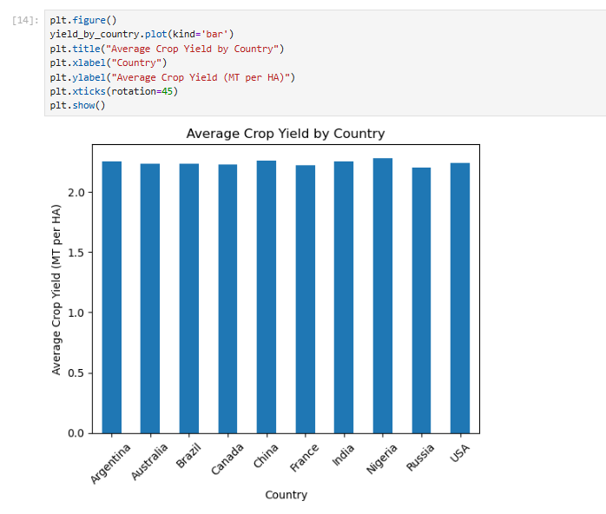

INSIGHTS AND FINDINGS
After performing detailed data analysis, the following expanded insights were observed:
- Crop yields differ considerably from country to country.
- Generally, when soil health is better, crop productivity also tends to be better.
- Extreme weather events have a negative impact on yields.
- Rising temperatures have different effects depending on the region.
- Countries with easier access to irrigation usually have more stable yields.
- The correlation matrix reveals a strong connection between soil health and yield.
- Forecasts suggest that yield trends will gradually change in the years ahead.
FUTURE SCOPE
To really boost this project's accuracy, make it easier to use, and broaden its real-world impact, we could take it even further with some smart and practical improvements, such as:
- Using advance forecasting models like ARIMA.
- Applying random forest or XG Boost for better prediction.
- Including satellite data. Developing a web dashboard.
- Adding real time weather API integration.
- Time series forecasting and advanced machine learning.
- Creating a farmer friendly decision support system.
CONCLUSION
This project looked at how climate stuff affects crop yields, and it used some data science methods to figure that out. It seems like the main things coming up were soil health, whether there is good irrigation, and those crazy weather events that mess everything up.
The forecasting part was interesting. It tried to predict what yields might look like down the road. They just went with a basic linear regression model, which is not fancy, but I think it still shows how machine learning could help with planning in farming.
Soil health keeps getting mentioned as a big deal, along with irrigation access. Extreme weather, yeah, that impacts productivity a lot.
Data like this can guide decisions for farmers and governments. Policymakers too, to keep food coming in steadily and make agriculture more sustainable. It’s kind of obvious once you see the patterns, but not everyone thinks about it that way. The model gives some ideas for the future, though its simple.
REFERENCE
- Food and Agriculture Organization (FAO). (2023). FAOSTAT Agricultural Production Data. Retrieved from https://www.fao.org/faostat/

- Intergovernmental Panel on Climate Change (IPCC). (2023). Climate Change 2023: Impacts, Adaptation and Vulnerability. Retrieved from https://www.ipcc.ch/

